BIAS BAR SETUP AND TECHNICAL NOTES

Purpose:
The function of a balance bar is to allow the adjustment of brake line pressure distribution between two master cylinders. This is accomplished through moving the balance bar pivot towards one master cylinder centerline or the other. If the pivot is perfectly centered between the pushrods, the force applied to each master cylinder will be equal. This is called the “neutral position” of the bias adjuster. If the pivot is moved closer to one pushrod or the other, then the master cylinders will receive differential forces that are inversely proportional to the distance between the balance bar pivot point and master cylinder center lines. Being able to move the pivot point allows the driver to make incremental adjustments to the braking characteristics of the car (front-to-rear brake bias) and to alter those characteristics to account for changes in fuel load, track conditions and handling of the car.

Pedal Assembly Types

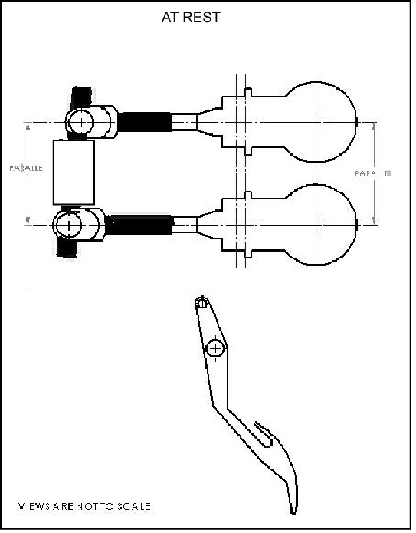There are 2 types of brake pedal assemblies in common usage today. The traditional type, and by far the most common, is the “push-type” or “compression” pedal assembly. In this type of pedal, the brake master cylinder pushrods are actuated by pushing the piston into the body of the master cylinder. The pressure outlet is mounted on the opposite end of the master cylinder body from the pushrod. The second option, which has become more prevalent recently, is the “pull-type” or “tension” pedal assembly. In this type of pedal assembly, the master cylinder piston is pulled through the master cylinder body by the master cylinder pullrod. The pressure outlet for the master cylinder is located on the pullrod side of the piston in the master cylinder body. This type of pedal assembly is typically found in open-wheel racecars, but has gained favor in all types of racing due to much reduced hysteresis.

Setting Up the Brake Balance Bar: Push Type
The brake balance bar is one of the most overlooked, and least understood, components on a racecar. As with all aspects of racecar assembly and preparation, careful attention to the geometry of the brake balance bar and brake pedal will yield great benefits.

To start with, look for proper installation of the brake balance bar bias adjuster and ensure that the brake balance bar pivot bearing is free to move within the pedal tube. The pedal tube can become distorted during installation, and if this is the case, then the tube can be reworked with a master cylinder hone until the bearing slides smoothly from one end of the tube to the other. The tube must be clean and sparingly lubricated with light oil or dry Teflon spray.

There are important installation and maintenance considerations for the push type pedal assembly. With the advent of the articulating push type pedal assembly (wherein the master cylinder is mounted through a spherical joint), there are numerous spherical bearings, heim joints and needle bearings in these systems. These components must be in proper working order and clean of debris and dirt to function properly. Any excess play in these components will adversely affect the control and release of the brake system, and should be avoided at all costs.

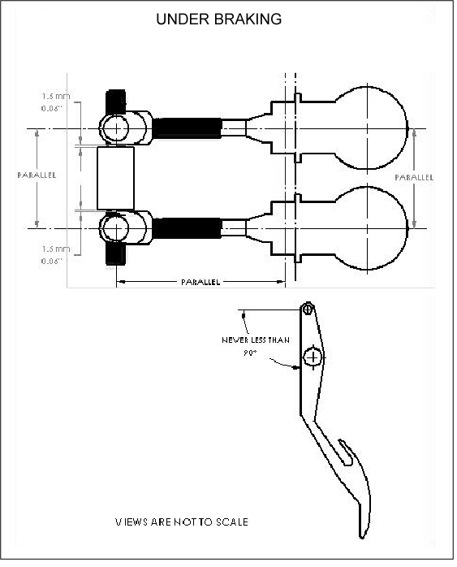Next, find the distance between the centerlines of the front and rear master cylinders. Typically, this could be 2½ inches, but is not critical. What’s critical is that this measurement, whatever it is, is exactly duplicated in the center-to-center distance of the clevises threaded onto the bias adjuster. This ensures that the master cylinder pushrods are actuated properly, minimizing any side loads applied to the master cylinder piston and bore.

With the clevises set on the bias adjuster, measure the distance between each clevis and the balance tube itself. If the clearance between each clevis and the balance tube is more than 0.060” (1.5mm) then shims must be added until the proper air gap is achieved. The total clearance of both clevises should be no more than .120” (3mm). This will prevent the balance bar from shifting while on the track and causing unpredictable change in the brake bias of the car.

With the balance bar connected to the master cylinders, and brake lines connected, the brakes should be bled. It is critical that front and rear brake circuits be bled simultaneously so that both master cylinders are allowed to use their full travel, and prevent binding or distortion of the bias adjuster.

Once satisfied that the clevises and pedal tube clearances have been properly set, now look at master cylinder pushrod length. The key is to set the bias adjuster so that it is perpendicular to the master cylinder centerlines when the brake pedal is under pressure.

Typically, this means that the front master cylinder pushrod will be 0.120”–0.200” (3mm-5mm) longer than the rear master cylinder pushrod when at rest. This is due to the front braking circuit having a larger fluid volume needed to feed the larger piston diameters of the front calipers. As a result the front master cylinder requires a higher feed rate than does the rear. If the pushrod lengths are equal then the feed rate of the rear master cylinder is too high relative to the front and that would result in the rear circuit “hitting” before the front.

So, with the pushrod lengths adjusted properly, the balance bar will be square with the pedal frame under compression, with the front and rear circuits engaging and releasing at the same moment.

Setting Up the Brake Balance Bar: Pull Type

In most cases, the pull type pedal assemblies are purchased and installed as assemblies. Furthermore, instead of the master cylinders being fixed and the balance bar moving with the brake pedal, in a pull type pedal assembly, the balance bar is fixed to the pedal frame and the master cylinders move with the balance bar adjuster through a spherical bearing mounting. This allows for adjustment of the brake bias, while at the same time keeps the pullrod actuating the piston through the centerline of the master cylinder bore.

There are important installation and maintenance considerations for the pull type pedal assembly. Firstly, there are numerous spherical bearings, heim joints and needle bearings in these systems. These components must be in proper working order and clean of debris and dirt to function properly. Any excess play in these components will adversely affect the control and release of the brake system, and should be avoided at all costs.

With all of the components in the system properly assembled and in good working order, we must set up the balance bar in much the same way as a push type pedal assembly. We will adjust the pull rod lengths so that the balance bar is square with the pedal frame under compression. However, the method we use to adjust the pull rod lengths is opposite to that of the push type pedal assembly. Typically, the front master cylinder pull rod will need to be shorter than that of the rear to accomplish this goal. As with the push type pedal, we can make fine adjustments to the pull rod lengths to alter the feed rate of their respective circuits. To increase the feed rat of a circuit in a pull type pedal, we will make that pull rod shorter. Conversely to decrease the feed rate of the circuit we will make the pull rod longer.

Brake Pedal Geometry
With the balance bar geometry now correct, it is now time to the brake pedal geometry. In order for the brake system to work properly, it is important that the brake pedal get hard before it crosses the vertical plane of the brake pedal pivot. If the brake pedal crosses the vertical plane of the pedal pivot (goes “over center”) then the mechanical advantage of the pedal, over the pushrods, will be lost. That would result in a loss of pedal feel and braking force. Adjust the pedal “over center” position with a separate pedal height adjuster, if available, or by lengthening both master cylinder pushrods by the same amount and until the desired pedal height is achieved. As a result, the throttle pedal may need to be adjusted to restore the proper heel-and-toe pedal relationship. If there is insufficient adjustment available then this can be accomplished by attaching a simple spacer to the throttle pedal.

